Subscriber’s Manual
by Richard W. Miller, Ph.D.
Editor of TripleScreenMethod
rmiller@triplescreenmethod.com
TripleScreenMethod.com
I developed the TripleScreenMethod approach to trading because I wanted to limit my trading to fundamentally sound stocks with value remaining in their price, specifically ones that are experiencing both earnings revisions and a pullback to a major area of support. Simply put, those are the three characteristics of a TSM trade.
Each weekend, a series of 47 screens are run, each meeting a set of fundamental criteria from a major service provider, e.g., IBD, Value Line, Forbes, Barrons, Zacks, Morningstar, Motley Fool and others. These provide a list of fundamentally sound stocks with institutional interest, most with multi-screen membership, that are then subjected to four constraints: price > $5, average daily volume > 100k share, 2-year PEG ratios < 1.5 and a Zacks ranking of 1 or 2 if market cap is less than $5 billion and 1, 2 or 3 if greater. Simply put, these are the best of the best for that week.
Personally, I’m a Ph.D. scientist for a large Chemical Company with expertise is in physical chemistry and statistics. I have been using that expertise to look at data and generate the TSM Daily Report nightly over the past 58 quarters now.
Dear Fellow Investor/Trader,
Welcome to TripleScreenMethod.com, and thank you for subscribing!
I have three goals in serving you:
- Each week, to bring you a list of stocks (usually ~150) that are fundamentally sound with value remaining in their price – from my view, simply the best of the best (the weekly TSM list in Excel).

- In each daily report, to highlight 1 to 4 stocks from that list that I would consider buying the next day.

- In each daily report, to highlight several groups of stocks from that list that meet certain modeling criteria:

- Those that will be reporting earnings in the current week;
- Those that have increased their earnings estimates during the past week;
- Those that have become new Zacks 1s ranked this week but were ranked 3 to 5 two weeks ago;
- Those that have become new Zacks 1 ranked over the past week;
- Those that are 1 or 2 Zacks ranked with a A or B Zacks style ranking, that are in a top 50 industry group in terms of performance (of 265 industries) and that have had either no change or an increased earnings revision and an improved analyst ranking; I call this group the ‘Best of the Best’;
- Those that are going ex dividend during the coming week.

- In each daily report, to provide a listing of all front month Puts from the TSM list that meet three criteria:

- They are far enough out-of-the-money to provide a risk cushion to a moderate drop in price (ideally 10% or greater);
- They generate enough premium to provide a 15% or greater annualized rate of return;
- They are out-of-the-money far enough to generate a 0 to -0.15 option delta (15% or less chance of finishing in the money);
- Their expiration date is between 10 and 30 days away.

The first three are short-term stock trading strategies, while the last one is an income producing strategy designed to produce a steady return on a pile of cash.

For Over 15 Years, the TSM has Excelled in Short-Term Trading
- $35,000 to $4,047,576
- 3,159 Winners to 1,086 Losers (74.4% Win Rate)
- 11,465% Overall Return Relative to S&P’s 136%
- 6.95 Days, on Average, in Trade

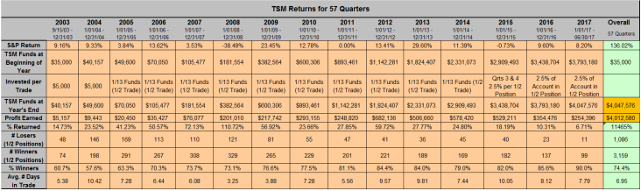

There is no question that the TSM method has worked through both good and bad times!

On a Quarter-by-Quarter Basis
- 43 of 58 Quarters have Beaten the S&P
- Only 2 Quarterly Losses While the S&P has had 16
- In 2008 the S&P Returned -38.5% and TSM +110.7%

Each TSM Pick in the Daily TSM Report will be Accompanied by its Fundamentals
- Zacks Rankings, Earnings Revisions and Watch List Membership
- An Entry Point abd ½ Position Exits Points

A typical TSM Daily Report will contain 1 to 4 buy recommendations in the following format. Note, when the postage size picture is pressed it blows up into the larger picture above.
Fundamentally Sound Stocks with Value Left in their Price and in the Process of Pulling Back to Support!
Special Strategies that Work for Fundamentally Sound Stocks
- TSM Earnings Report Snap Back

TSM has a negative reaction to its earnings report either before market opens or after it closes.

Because the TSM stocks are fundamentally sound, they have a great chance to snap back quickly.

Essentially, the market makers or the specialist anticipates the negative reaction and opens the TSM stock low – often lower than is justified -- because they will be buyers at the open.

The stock then snaps back during the day.

We want to trade like the specialist or market maker, essentially buying the open too.

RCL is a recent example. It opened low, then bounced back over the next hour for a $4 gain.

Fundamentally sound stocks will always be supported by institutional buying. That provides a safety net for the TSM trades.

- TSM Earnings Estimate Increase in Past Week
If earnings drive a stock’s price over the long term, earnings estimate increases drive it over the short term, especially for fundamentally sound stocks with value – TSM stocks. Each evening I run a screen that generates all the TSM stocks in which analysts have increased this year’s earnings estimate by more than 2% over the past week. If I do that each evening, I identify those that have changed over the last day. Of course, as soon as this happens, institutions start building positions.
The following shows that portion of the TSM Daily Report generated for 2/12/15 for a number of special screens, the 2% earnings estimate being one. The postage size tables can be blown up to reveal the fundamentals of each.
On Wednesday (2/11/15) I demonstrated (with $ on the table) the power of combining TSM stocks with earnings estimate increases.
In the afternoon, I bought 500 shares each (400 for TNP as I don't like to buy stocks under $10) of 8 TSM stocks, each of which had increased its earnings estimate by greater than 2% over the past week. I then sold all 8 the next day. All were profitable making me $1,702 profit after commissions. If I had optimized the buy and sell points, I could have made nearly twice that. Clearly, earnings drive price over the longer term and earning's estimate increases drive price immediately. The questions are: Is the stock fundamentally sound ? (yes, it's a TSM stock) Does the stock have value remaining at its current price? (yes, as again it's a TSM stock) Will I be able to hop on board early for the inevitable ride upward? (yes, if you monitor the TSM report each night).
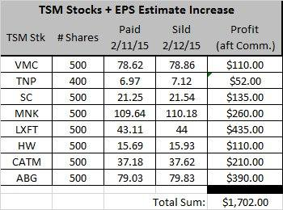

Two days later, I repeated the performance.

Special Screens with an Emphasis on Limiting Drawdowns
As a professional statistician, I've spent a lot of time modeling and screening stocks using a combination of their fundamentals and technicals. While it's relatively easy to find sound screens that generate powerful returns, it's more difficult to find screens that didn't suffer big drawdowns when the market turned down, e.g., 2001 and 2008.
- An Example – The Fundamentals Based Pullback Screen
Using a combination of fundamentals (change in EPS estimates, Zacks ranking, Price-to-Sales ratio, 2 year PEG ratios) and technicals (price, volume, pullback) criteria, this screen identifies 2 stocks each Monday morning to hold into Friday's close, unless this 2-stock position fell 5% during the week.
As shown in the chart below, over the past 14.44 years (751 weeks) a pullback technical (worst price performance in preceding week) outperformed a breaking higher technical (best price performance in the preceding week): the first strategy grew the account from $10,000 to $911 million, while the second would have grown that same $10,000 to $47,000 (obviously, pullback strategies are far superior to breakout strategies). Note, over that same period, the S&P 500 would have grown the $10,000 to $17,000. Clearly, it pays to incorporate pullback strategies in your screening.
More important to me than the pullback's super returns is the max draw down encountered and my ability to withstand it: 22.24% for the pullback strategy and 54.72% for the S&P. Note though, in the chart, if no stop loss had been used, there would have been over a 71% draw down using this strategy.
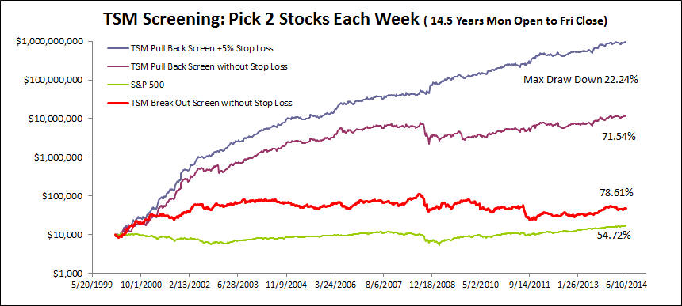

The Short Put Strategy – You Become a Stock Price Insurer
- In addition to trading TSM stocks, writing Puts on these same fundamentally sound stocks provides a source low-risk income (in a world where few such opportunities exist for the saver).
(Triplescreenmethod.com/Special_Report/140920_SpecialReport_WritingPuts.asp)
Each TSM Daily Report is accompanied by a list of Puts that are candidates for the next day’s Short Put trades. Each is graded for % Downside Protection (14.5% for KORS’ $62.5 Feb Put expiring in 22 days) and its Annualized Yield (13.3% for KORS and 35.9% for SYNA)

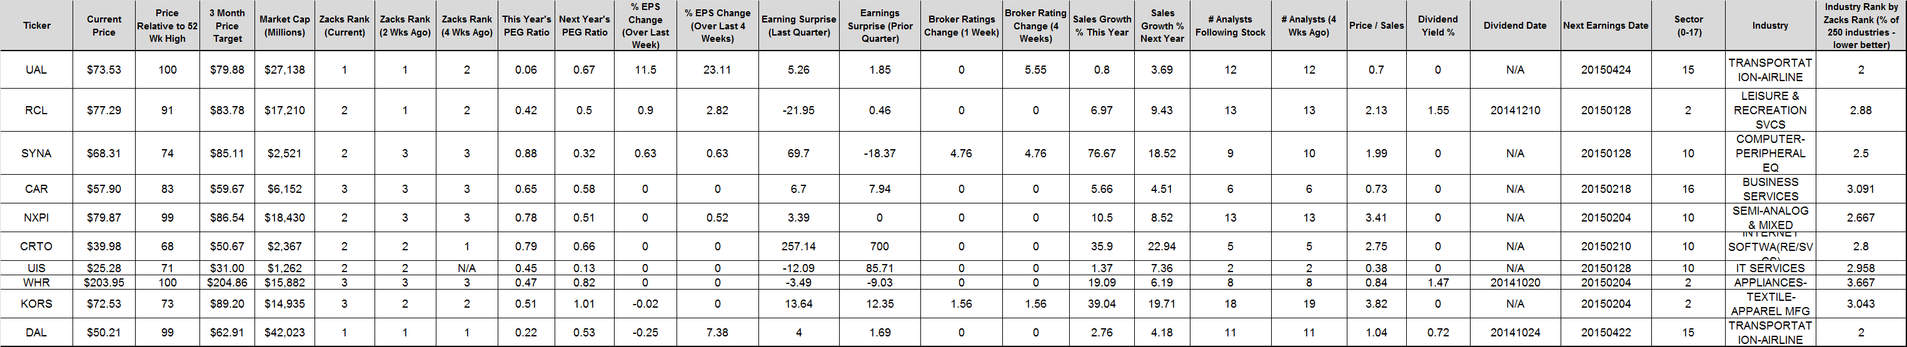
Of course, a complete list of fundaments accompanies the above list.

This is my personal favorite trading strategy.
The Short Put Strategy Continues to be a Low Risk Income Producer

Unlike owning stock shares where you win when their price grows, the Short Put Strategy is a winner when the underlying stock price goes up a lot or a little, when the stock price remains constant or when the stock price drops a little (the downside protection percentage). It only loses when the stock price drops a lot, but even then not as much as owning the stock shares outright (the premium cushion).

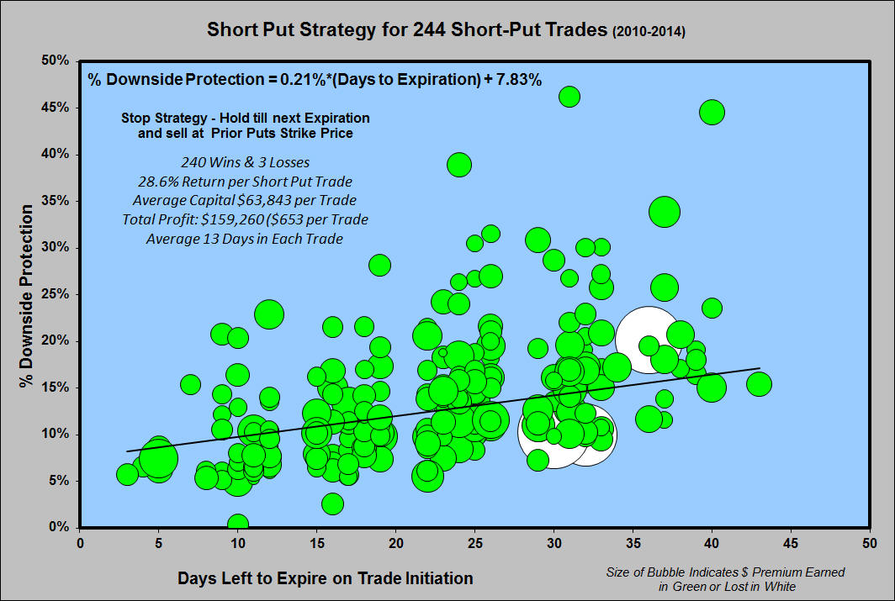

Interested in the TSM Method?
Go to TripleScreenMethod.com and Sign Up for a $25 Monthly Membership.

