Subscriber’s Manual
by Richard W. Miller, Ph.D.
Editor of TripleScreenMethod
rwmill@yahoo.com
TripleScreenMethod.com

I developed the TripleScreenMethod approach to trading because I wanted to limit my trading to fundamentally sound stocks with value remaining in their price, specifically ones that are experiencing both upward earnings revisions and a pullback into a major area of support. Those are the three criteria that define the ideal TSM trade.
Each weekend, I run a series of up to 200 screens, each one requiring stocks meet a specific set of fundamental and sometimes technical criteria as defined by a major service provider, e.g., IBD, Value Line, Forbes, Barrons, Zacks, Morningstar, Motley Fool, Vector Vest and others. Most stocks in the TSM list hold membership in multiple screens, but to be a member of that week’s TSM list, each one has to hold membership in at least one.
The TSM list is further culled by a series of constraints: price > $10, average daily volume > 100k share, Price/Sales <=3, analyst average rating change >/= 0, earnings estimate change > -0.3%, an A or B Zacls Style ranking, and a Zacks ranking of 1 or 2 if market cap is less than $10 billion and 1, 2 or 3 if greater. Simply put, these are fundamentally the best stocks to trade or invest in that week.
Dear Fellow Investor/Trader,
Welcome to TripleScreenMethod.com, and thank you for subscribing!
I have three goals in serving you:
- Each week, to bring you a list of stocks (usually ~150) that are fundamentally sound with value remaining in their price – from my view, simply the best of the best (the weekly TSM list in Excel).

- In each daily report, to highlight 1 to 4 stocks from that list that I would consider buying the next day and provide a list of my trades as I make them during the day.

- In each daily report, to highlight several groups of stocks from that list that meet certain modeling criteria:

- Those that will be reporting earnings in the current week;
- Those that have increased their earnings estimates during the past week;
- Those that have become new Zacks 1s ranked this week but were ranked 3 to 5 two weeks ago;
- Those that have become new Zacks 1 ranked over the past week;
- Those that are 1 or 2 Zacks ranked with a A or B Zacks style ranking, that are in a top 50 industry group in terms of performance (of 265 industries) and that have had either no change or an increased earnings revision and an improved analyst ranking; I call this group the ‘Best of the Best’;
- Those that are going ex-dividend or reporting earnings during the coming week.

- In each daily report, to provide a listing of all front month Puts from the TSM list that meet three criteria:

- They are far enough out-of-the-money to provide a risk cushion to a moderate drop in price (ideally 10% or greater);
- They generate enough premium to provide a 15% or greater annualized rate of return;
- They are out-of-the-money far enough to generate a 0 to -0.15 option delta (15% or less chance of finishing in the money);
- Their expiration date is between 10 and 30 days away.

The first three are short-term stock trading strategies, while the last one is an income producing strategy designed to produce a steady return on a pile of cash.

For Over 15 Years now, the TSM has Excelled in Short-Term Trading
- $35,000 to $4,047,576 between 2003 and 2017
- 3,159 Winners to 1,086 Losers (74.4% Win Rate)
- 11,465% Overall Return Relative to S&P’s 136%
- 6.95 Days, on Average, in Each Trade

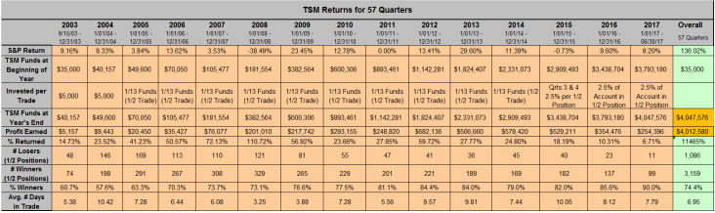

There is no question that the TSM method has worked through both good and bad times!

On a Quarter-by-Quarter Basis Over This Period
- 43 of 58 Quarters have Beaten the S&P
- Only 2 Quarterly Losses While the S&P has had 16
- In 2008 the S&P Returned -38.5% and TSM +110.7%

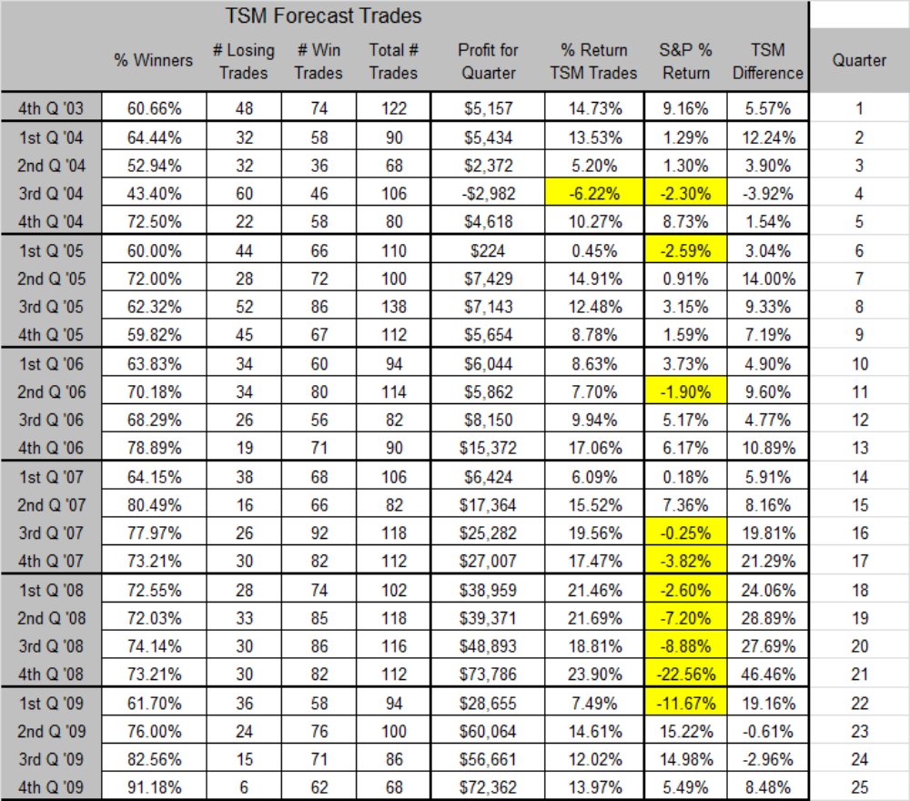

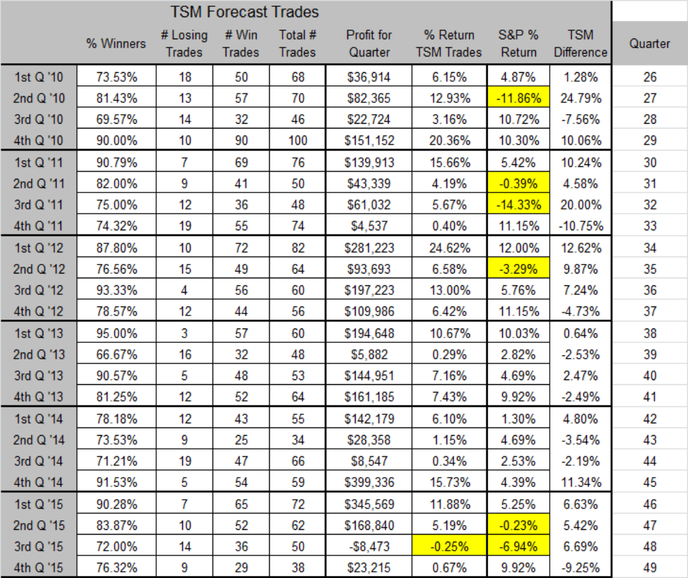

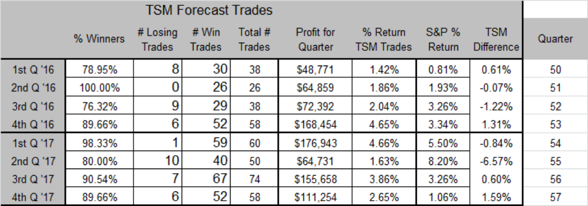

Each TSM trade in the Daily TSM Report will be accompanied by the Zacks report on its fundamentals; this report will be updated during the day as trades are made.

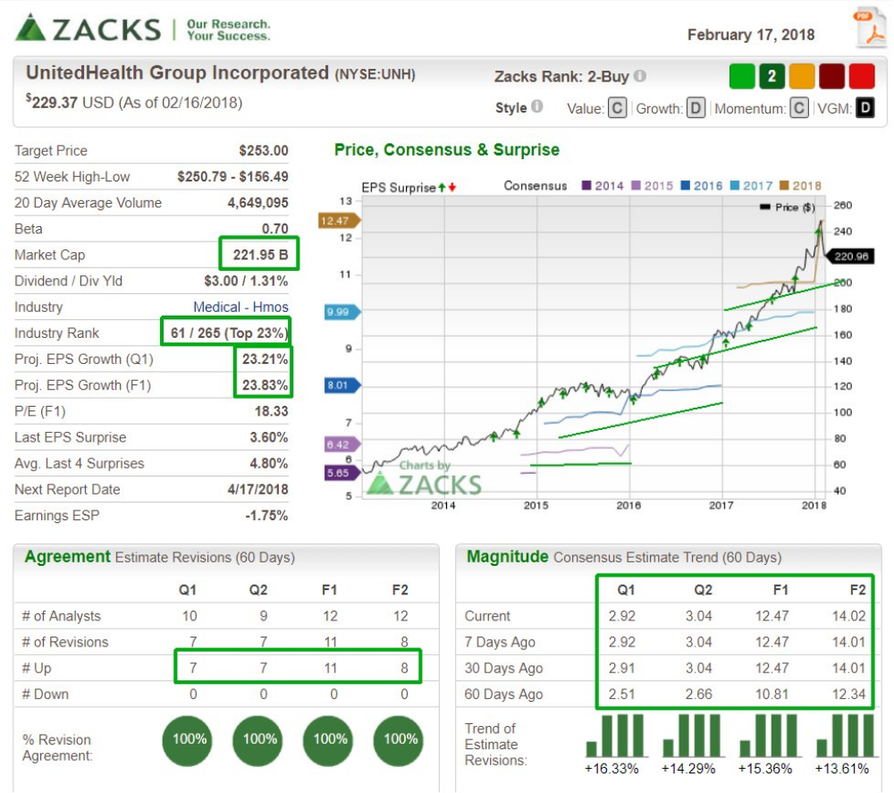

A typical TSM Daily Report will contain 1 to 4 buy recommendations in the following format. Note, when the postage size picture is pressed it blows up into the larger picture above.
Fundamentally Sound Stocks with Value Left in their Price and in the Process of Pulling Back to Support!
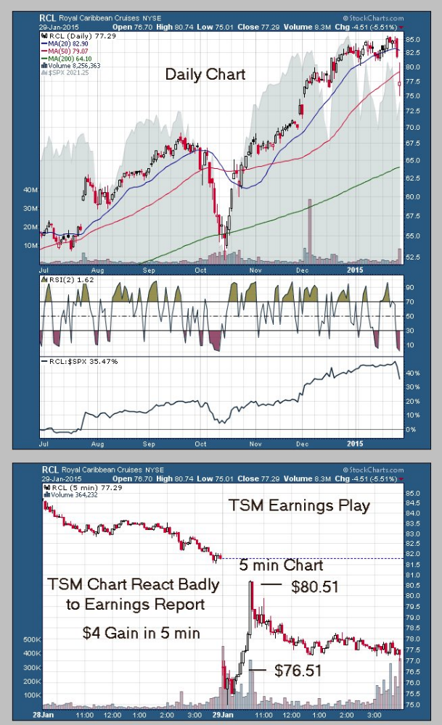
Special Strategies that Work for Fundamentally Sound Stocks
- TSM Earnings Report Snap Back

TSM has a negative reaction to its earnings report either before market opens or after it closes.

Because the TSM stocks are fundamentally sound, they have a great chance to snap back quickly.

Essentially, the market makers or the specialist anticipate the negative reaction and open the TSM stock low – often lower than is justified -- because they will be buyers at the open.

The stock then snaps back during the day.

We want to trade like the specialist or market maker, essentially buying the open too.

RCL is a recent example. It opened low, then bounced back over the next hour for a $4 gain.

Fundamentally sound stocks will always be supported by institutional buying. That provides a safety net for the TSM trades.

- TSM Earnings Estimate Increase in Past Week
If earnings drive a stock’s price over the long term, earnings estimate increases drive it over the short term, especially for fundamentally sound stocks with value – TSM stocks. Each evening I run a screen that generates all the TSM stocks in which analysts have increased this year’s earnings estimate by more than 2% over the past week. If I do that each evening, I identify those that have changed over the last day. Of course, as soon as this happens, institutions start building positions.
The following shows that portion of the TSM Daily Report generated for 2/12/15 for a number of special screens, the 2% earnings estimate being one. The postage size tables can be blown up to reveal the fundamentals of each.
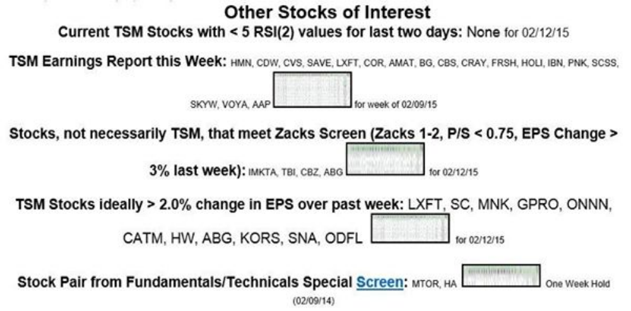
On Wednesday (2/11/15), I demonstrated (with $ on the table) the power of combining TSM stocks with earnings estimate increases.
In the afternoon, I bought 500 shares each (400 for TNP as I don't like to buy stocks under $10) of 8 TSM stocks, each of which had increased its earnings estimate by greater than 2% over the past week. I then sold all 8 the next day. All were profitable making me $1,702 profit after commissions. If I had optimized the buy and sell points, I could have made nearly twice that. Clearly, earnings drive price over the longer term and earning's estimate increases drive price immediately. The questions are: Is the stock fundamentally sound ? (yes, it's a TSM stock) Does the stock have value remaining at its current price? (yes, as again it's a TSM stock) Will I be able to hop on board early for the inevitable ride upward? (yes, if you monitor the TSM report each night).
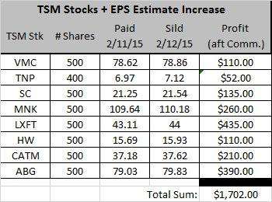

Two days later, I repeated the performance.
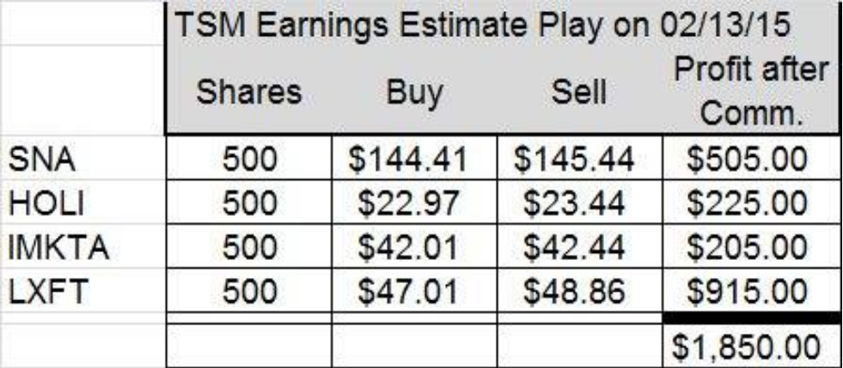

Again, over the long term, a stock’s price is driven by a company’s earnings. The following chart clearly shows that relationship for 562 stocks Zacks ranked a 1 or 2 on 8/21/20. These stocks were placed into groups of 25 based on their average price change over the past three months (a technique used to minimize noise caused by extraneous effects. Clearly, price rose as earnings rose over the three-month period.
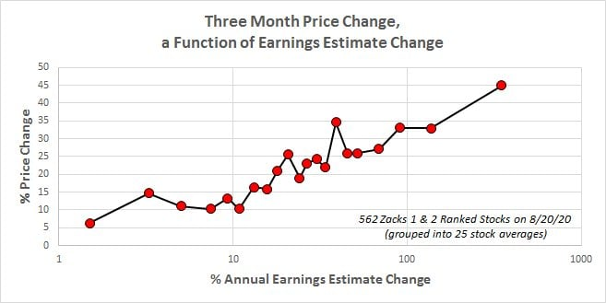
If you want to hold stocks over the long term, make sure their company earnings are rising. On the other hand, if you’re a short-term trader, trade those stocks that have had upward estimate revisions over the past 30 days.
Special Screens with an Emphasis on Limiting Drawdowns
As a professional statistician, I've spent time modeling and screening stocks using a combination of their fundamentals and technicals. While it's relatively easy to find sound screens that generate powerful returns, it's more difficult to find screens that didn't suffer big drawdowns when the market turned down, e.g., 2001 and 2008.
- An Example – The Fundamentals Based Pullback Screen
Using a combination of fundamentals (change in EPS estimates, Zacks ranking, Price-to-Sales ratio, 2 year PEG ratios) and technicals (price, volume, pullback) criteria, this screen identifies 2 stocks each Monday morning to hold into Friday's close, unless this 2-stock position fell 5% during the week.
As shown in the chart below, over the past 14.44 years (751 weeks) a pullback technical (worst price performance in preceding week) outperformed a breaking higher technical (best price performance in the preceding week): the first strategy grew the account from $10,000 to $911 million, while the second would have grown that same $10,000 to $47,000 (obviously, pullback strategies are far superior to breakout strategies). Note, over that same period, the S&P 500 would have grown the $10,000 to $17,000. Clearly, it pays to incorporate pullback strategies in your screening.
More important to me than the pullback's super returns is the max draw down encountered and my ability to withstand it: 22.24% for the pullback strategy and 54.72% for the S&P. Note though, in the chart, if no stop loss had been used, there would have been over a 71% draw down using this strategy.
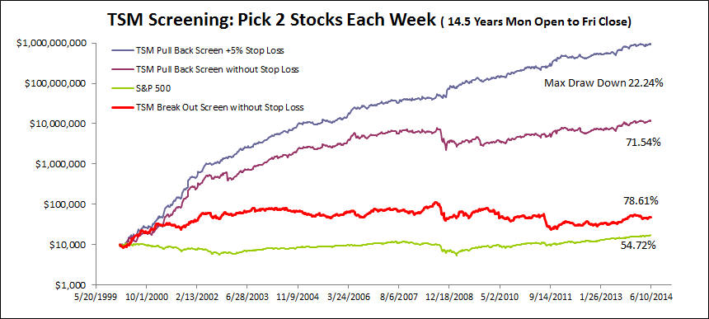

The Short Put Strategy – You Become a Stock Price Insurer
- In addition to trading TSM stocks, writing Puts on these same fundamentally sound stocks provides a source low-risk income (in a world where few such opportunities exist for the saver).
(Triplescreenmethod.com/Special_Report/140920_SpecialReport_WritingPuts.asp)
Each TSM Daily Report is accompanied by a list of Puts that are candidates for the next day’s Short Put trades. Each is graded for % Downside Protection (14.5% for KORS’ $62.5 Feb Put expiring in 22 days) and its Annualized Yield (13.3% for KORS and 35.9% for SYNA).
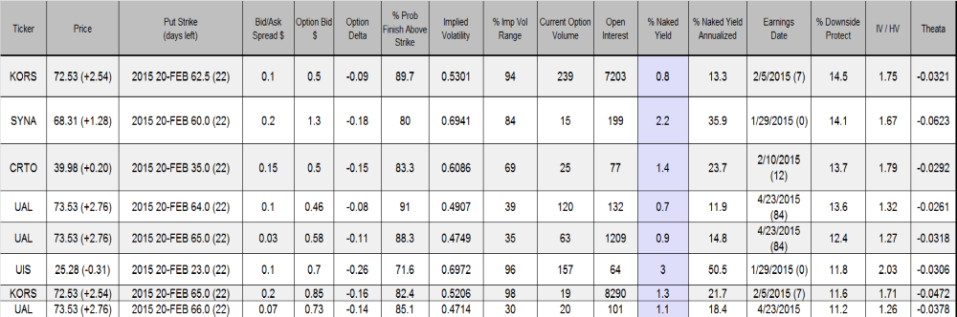

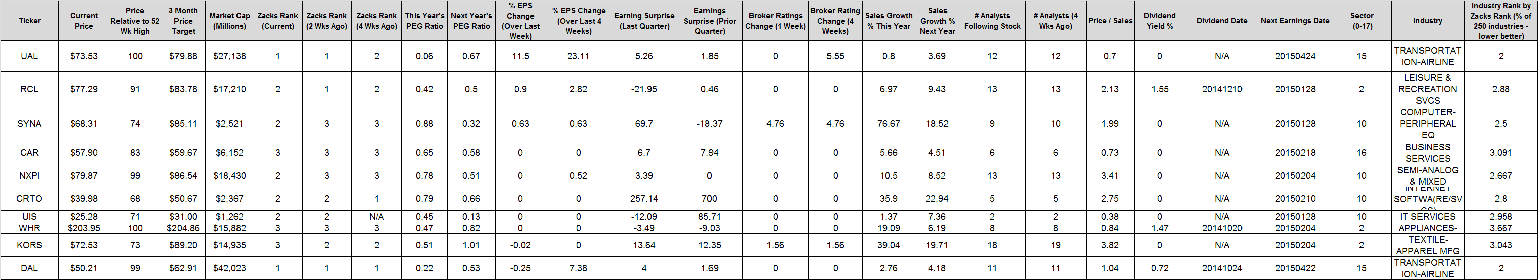
Of course, a complete list of fundaments accompanies the above list.

This is my personal favorite trading strategy.
The Short Put Strategy Continues to be a Low Risk Income Producer

Unlike owning stock shares where you win when their price grows, the Short Put Strategy is a winner when the underlying stock price goes up a lot or a little, when the stock price remains constant or when the stock price drops a little (the downside protection percentage). It only loses when the stock price drops a lot, but even then not as much as owning the stock shares outright (the premium cushion).

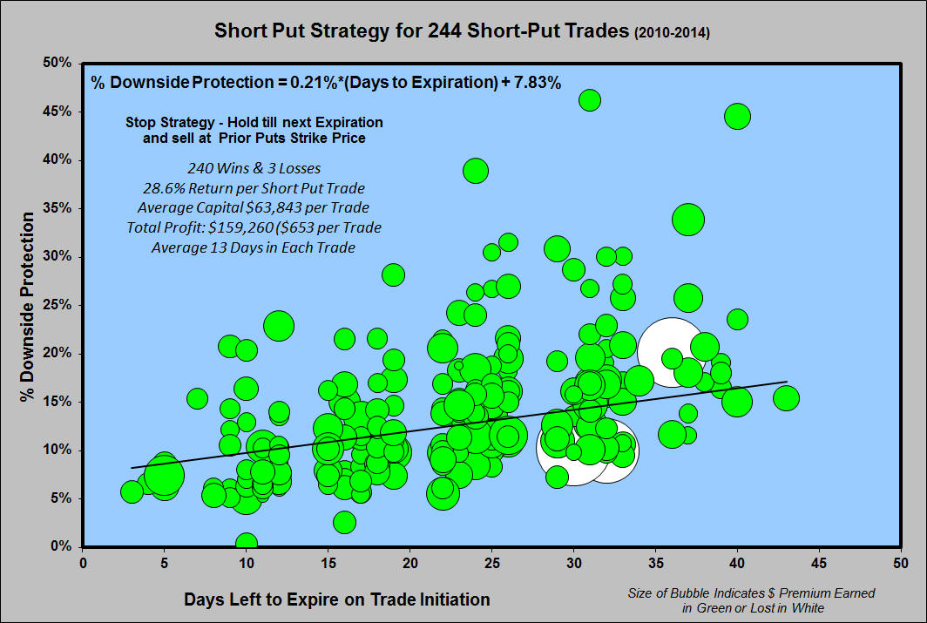

The Insider Trading Strategy – Trade with Those Having the Most Information about Company Fundamentals.
Company Insiders have the most knowledge about their respective companies. While they sell shares for a number of reasons, their buys reflect their belief that share price is moving higher. TSM watch list # 8 is a listing of Insider Buys for current list of TSM stocks that have occurred over the past three months. Included are the number of buys, the type of insider, the number of shares, and what their share price was.
The insider list presented in the 8/21/20 TSM report showed that the CEO for CWH had made 13 trades, spending over $1.5 million – the latest yesterday. The following chart tracks his trades and shows yesterday’s closing price. Clearly, he felt CWH shares were going higher. Note, price fell over his last trade due to an announcement that 6 million shares would be sold by the company at a price between $35 and $35.5. He invested another $250k at the resulting pullback.
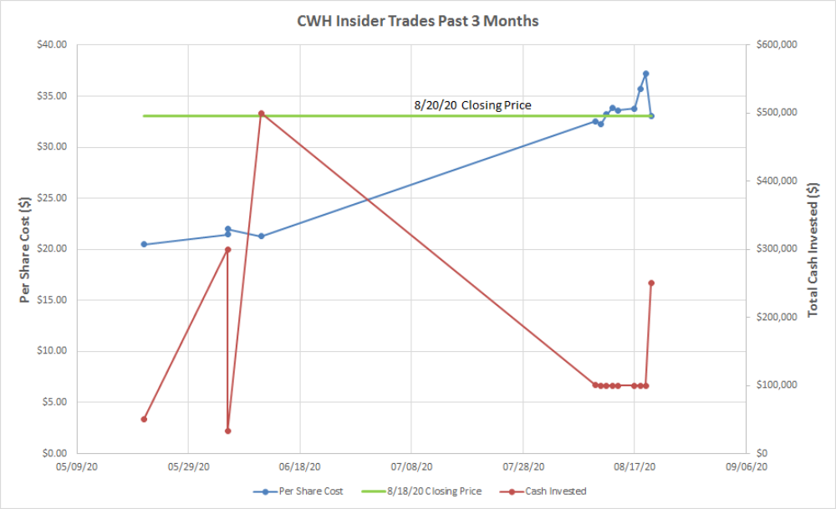

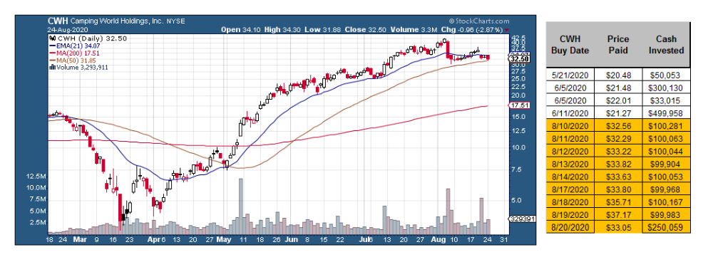

Technical Indicators for TSM Stocks
Each Daily TSM Report has a section (shown below) that lists those TSM stocks meeting 9 technical criteria, e.g., gaped higher, abnormally high volume, and others at the close of the prior day. Additionally, all stocks (TSM and others) with an A or B style ranking that became a Zacks 1 in the prior week are listed.

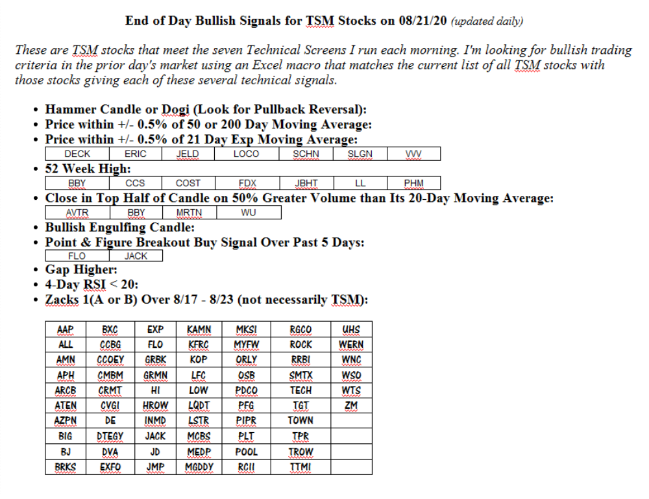

Interested in the TSM Method?
Go to TripleScreenMethod.com and Sign Up for a $25 Monthly Membership.

